Jennifer Pero

Last revision: 4/11/2023

Introduction to Instances in AWS

Table of contents

Introduction 3

What is an instance? 3

Types of instances 3

Benefits of instances 4

Why use AWS for instances? 4

Creating a Windows Server Instance 4

Configuring security settings 6

Finding your instance’s security group 6

Adding an inbound rule 7

Connecting to your instance 9

Conclusion 10

Additional Resources 11

## Introduction

For many businesses and personal projects, maintaining a physical server is a costly endeavor with many security and recovery concerns. Instances are a cost-effective solution that is 100% virtual, secure, and remotely accessible. Amazon Web Services (AWS) is one of the best options for creating scalable instances based on your needs.

This guide will cover the basics of instances and why you should use AWS for instances. You will then learn how to use AWS to create, configure, and connect to a Windows Server instance. Only general knowledge of cloud computing and networking concepts like IP addresses, Remote Desktop Protocol (RDP), network traffic, and the command prompt is required to understand this guide.

## What is an instance?

An *instance* is a virtual computer that runs on the AWS Cloud. Instances look and act like any other computer; you can browse the internet, host servers, run applications, etc. They are even powered by virtual versions of physical hardware like CPUs and RAM.

The only difference between instances and physical computers is that instances are entirely virtual; you can connect to an instance from your own computer, even if it uses a different operating system!

### Types of instances

Not all instances are built the same, from the operating system to the virtual hardware specs. In AWS you can select an instance type that best suits your computational needs, and each type offers different instance families with various sizes and features. AWS offers six instance types:

* **General Purpose:** Balances computing, networking, and memory resources. Best for web servers and small application servers.
* **Compute Optimized:** Offers high computation power. Best for gaming servers and data models requiring high performance.
* **Memory Optimized:** Processes large datasets quickly for fast performance. Best for databases and analytics.
* **Accelerated Computing:** Uses hardware accelerators to efficiently process data. Best for graphics applications.
* **Storage Optimized:** Stores large volumes of data. Best for data warehousing.
* **HPC Optimized:** Affordable alternative for high-performance computing.

In this guide, you will create a *t2.micro* instance, a general-purpose instance from the T2 family. When creating an instance, t2.micro is normally the default selection because it’s free-tier eligible and has a baseline performance. For a detailed look at instance types and their different families, sizes, and specifications, see [Amazon EC2 Instance Types](https://aws.amazon.com/ec2/instance-types/).

**Note:** Free-tier eligibility means that, under the AWS free tier, you can run a t2.micro instance for 750 hours per month for the first 12 months after creating your AWS account. Once your instance passes the 750-hour mark, you will be charged by the hour that your instance is running. For more pricing details, see [Amazon EC2 Pricing](https://aws.amazon.com/ec2/pricing/?trk=36c6da98-7b20-48fa-8225-4784bced9843&sc_channel=ps&ef_id=Cj0KCQjwiZqhBhCJARIsACHHEH92ne1Qjwdj6EQgHboPctF88XLT_CfJm5ALRpWO5muybKSP_5pp26QaAkDxEALw_wcB:G:s&s_kwcid=AL!4422!3!536451475355!e!!g!!ec2%20pricing!11198711716!118263956828).

### Benefits of instances

On top of flexibility, instances offer a lot of benefits over physical servers and computers:

* **Cost-effective:** Instances eliminate the need to invest in hardware, staffing, or physical space to house a data center.
* **Scalable:** You can adjust capacity anytime, only paying for what you need. Physical data centers require guessing capacity, leading to spending too much money maintaining servers you don’t need, or not having enough servers.
* **Reliable:** In case of an outage, natural disaster, or other failures, instances are easily recoverable or replaceable as they're in the cloud. You can spend less time on maintenance and more on satisfying your customers.

## Why use AWS for instances?

*Amazon Web Services (AWS)* is a cloud computing service powered by Amazon. AWS uses the *Elastic Compute Cloud (EC2)* service to run and store instances. On top of instances, AWS offers a variety of free and paid cloud-computing products like VPCs, databases, APIs, and more.

Instances are the same as virtual machines offered by VMWare and the Google Cloud Platform (GCP). What makes AWS stand out is that it has more data centers around the globe, delivering greater accessibility and more storage and RAM. AWS is best for businesses looking to move away completely from physical data centers and legacy systems.

## Creating a Windows Server Instance

You can create and configure instances through the *EC2 Dashboard.* You will create a t2.micro instance that uses the Windows Server operating system. *Windows Server* resembles the regular Windows OS but with additional programs and features specifically designed for server management. To create a Windows Server t2.microinstance:

1. Log in to the [AWS Console](https://us-east-2.console.aws.amazon.com/console/home?region=us-east-2).
2. Graphical user interface, application

   Description automatically generatedType **EC2** into the search bar. Click the **EC2** result that should be the first to appear under **Services**. You are now in the EC2 Dashboard.

Figure 1: EC2 Dashboard

1. Click **Instances** under the**Icon

   Description automatically generatedInstances** dropdown on the left side menu. This is where you'd see each of your instances listed as rows in a table. It should be empty.
2. Click **Launch instances**. Give your instance a name.
3. Select an operating system in the**Application and OS Images** section. Select **Windows** and keep the free-tier version that is already selected for you.
4. Select t2.micro under the**Instance type**. It may already be selected for you.
5. Click **Create new key** pair under **Key pair (login).**
6. Enter a name for your key pair and check the **.pem** radio box for the file format.
7. Click **Create key pair**. Your key pair file will be downloaded to your computer.
8. Keep the remaining settings as their defaults and select **Launch instance**.

Your instance will now appear on the Instances page and should say it's**** Running in the **Instance state** column. If not running, right-click anywhere on your instance row and click **Start instance**.

Figure 2: Instance page with a new launched instance.

## Configuring security settings

AWS provides a lot of customization for an instance’s security settings. You can modify most of these settings by adding and editing rules in your instance’s security group. A *security group* is your instance’s firewall that controls inbound and outbound traffic. You can create your own security groups that you can assign to one or multiple instances, or let AWS create and assign one for you.

### Finding your instance’s security group

When you launched your first instance, you allowed AWS to assign it to a security group instead of creating your own. To find your instance’s security group:

1. 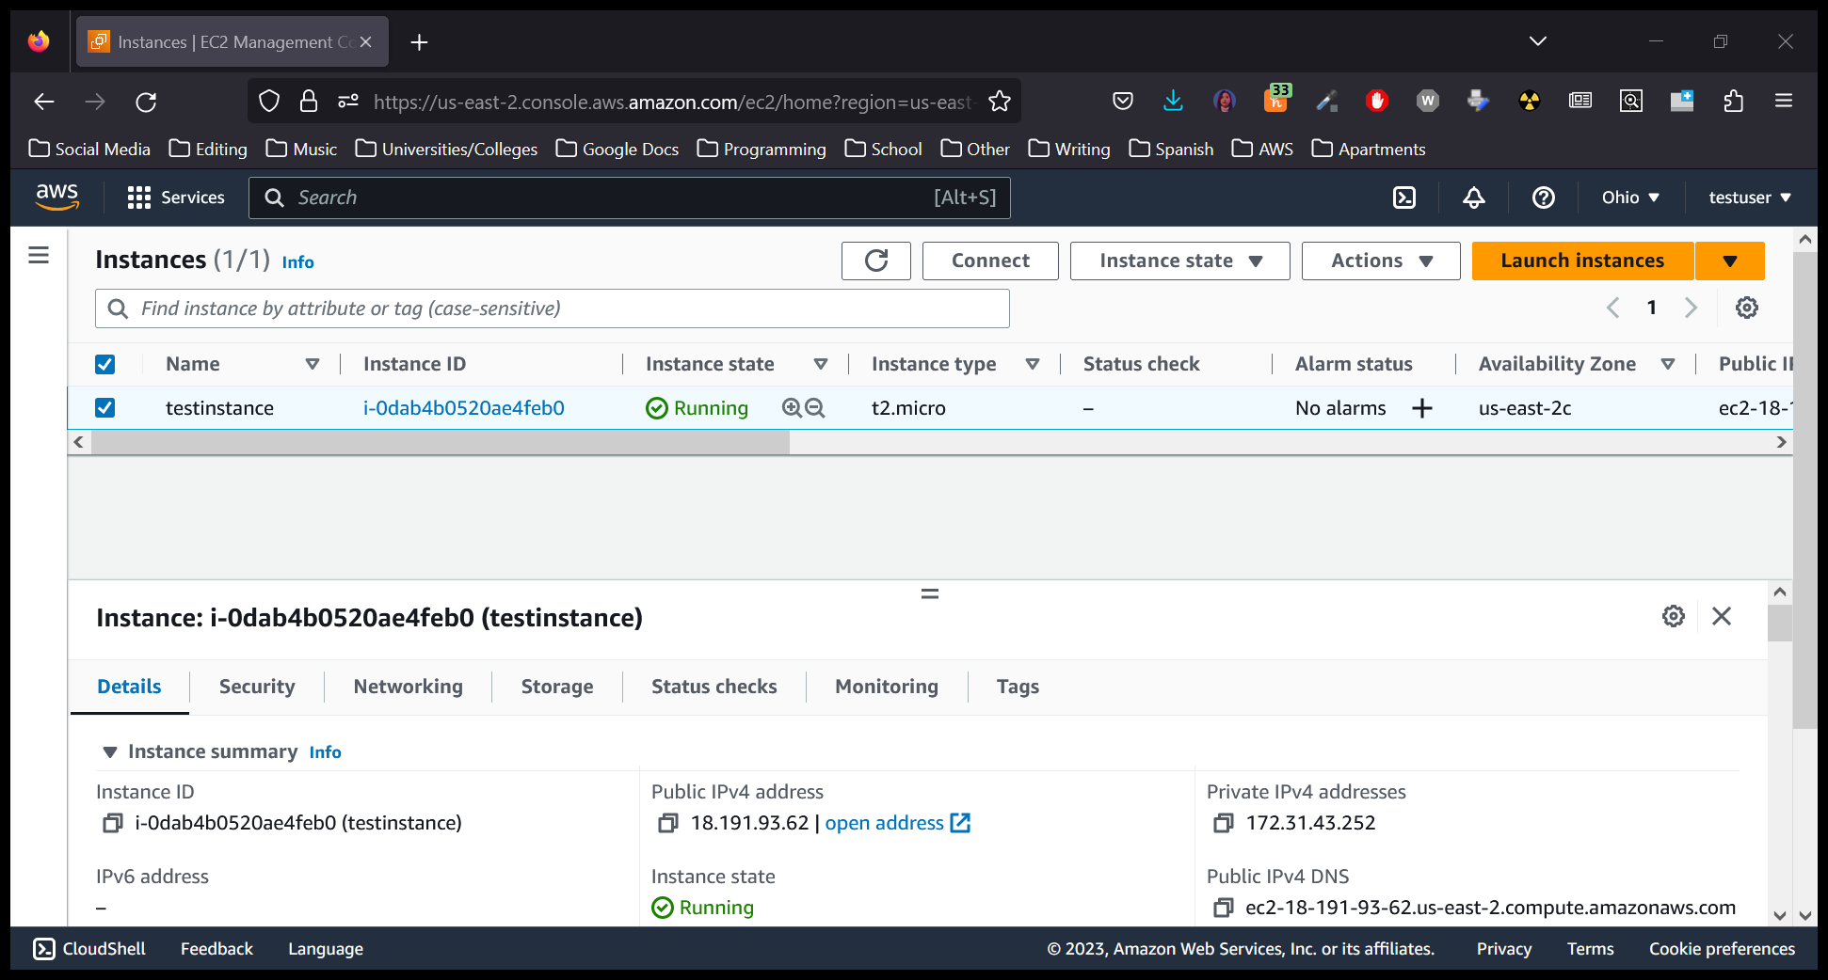Select your instance on the **Instances** page. A panel will appear at the bottom showing your instance’s IP addresses, security, monitor checks, and other details.

Figure 3: Instance bottom panel showing IP and security details.

1. Click the **Security** tab. Under **Security Groups** you will find your instance’s security group listed. It will probably be named something like **launch-wizard-1**.
2. 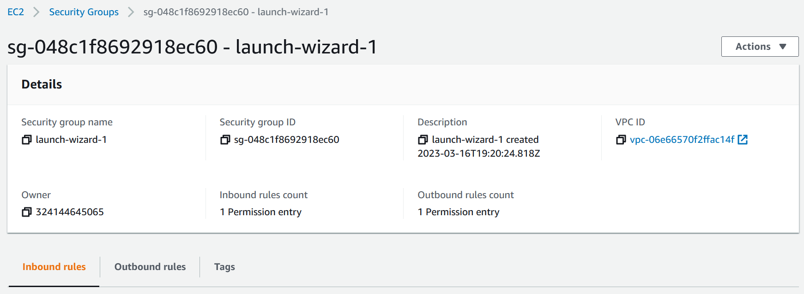Click your security group. This will redirect you to a page listing your security group’s details and allows you to edit its inbound and outbound rules.

Figure 4: Security groups page for launch-wizard-1.

### Adding an inbound rule

Let’s say you want your actual computer and your instance to be able to exchange data. Security groups block all inbound traffic by default, even if you could successfully connect to that instance. You can test this by pinging your instance’s public IPv4 address from your computer. *Pinging* tests the connection between two IP addresses.

To ping your instance from your computer, open your command prompt or terminal and type ping followed by the public IPv4 address of your instance which you can find in the **Details** tab of the bottom panel. The output will likely display Request timed out multiple times, meaning the instance IP is unreachable.

Figure 5: "Request timed out" shows when pinging your instance IP.

To fix this, you can add a rule in the security group’s inbound rules to allow pings from your computer/IP address. To add an inbound rule to your security group:

1. Click the **Inbound rules** tab from your security group’s page.
2. Graphical user interface, text, application

   Description automatically generatedClick **Edit inbound rules**. This will show a page listing the inbound rules.

Figure 6: Inbound rules for launch-wizard-1, which is currently empty.

1. Click **Add rule**.
2. Select the following options from the dropdowns in this rule:
   * **Type**: Custom ICMP – IPv4.
   * **Protocol**: Echo Request.
   * **Source**: My IP.
3. Click **Save rules**.

Ping your instance again. The output should now print Reply from followed by the instance’s public IP address and ping statistics and information. This is because the new inbound rule now allows traffic just from your IP.

**Note:** Editing outbound rules works just like editing inbound rules, but is instead done in the **Outbound rules** tab.

## Connecting to your instance

Now that your instance is running and security configured, you're now ready to connect to your instance. There are different ways to connect to a Windows instance, but the easiest way is to download the instance as a .rdp file and log into it using the password decrypted from the key pair file that you downloaded earlier. To connect to your instance:

1. Right-click your instance and select **Connect** (or click the **Connect** button at the top).
2. Select the **RDP client** tab, then click  **Download remote desktop file**. A .rdp file with the same name as your instance will be downloaded to your computer.
3. Click **Get password**, and then click  **Upload private key file**.
4. 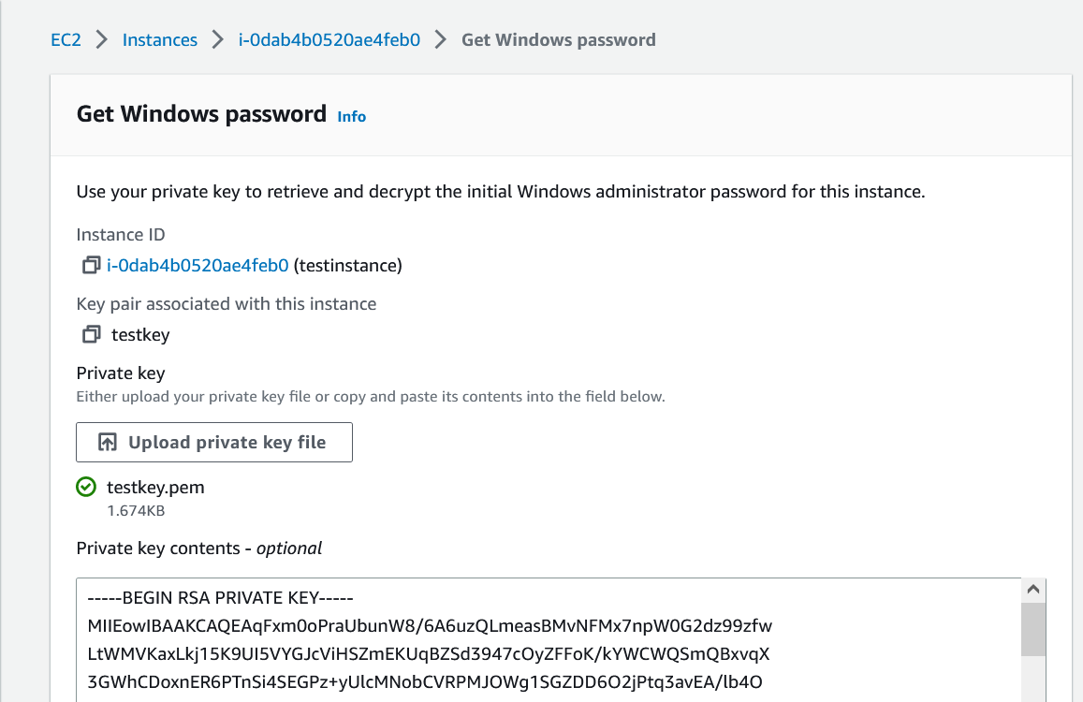Browse and open the key-pair .pem file you downloaded in

Figure 7: Get Windows password page where you'll upload your private key file.

1. **Creating a Windows Server** Instance. The contents of your private key should appear in the textbox below (the screenshot does not show the full password).
2. Click **Decrypt password**, and your instance password now appears. Copy the password.
3. Open the .rdp file you downloaded earlier. The Remote Desktop Connection client may warn you that this remote connection can’t be identified. Click **Connect**.
4. Paste your instance password into the **Password** textbox and then click **OK**. Your instance will now open.

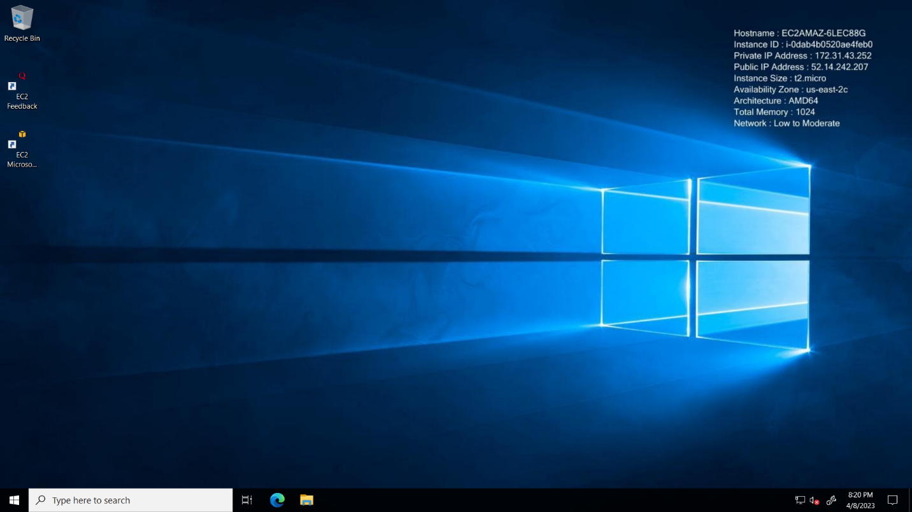Your instance will resemble a Windows Server desktop with the wallpaper displaying your instance details, such as the IP address.

Figure 8: A connected Windows Server instance.

Feel free to play around by browsing the internet, running an application, or hosting a server. When finished, click the **X** button at the top to close the instance.

**Caution:** To avoid being charged after the 750-hour mark, you can stop your instance from running by right-clicking your instance on the Instances page and selecting **Stop Instance**. This will change the value in the **Instance state** column to **Stopped**. To delete your instance, right-click your instance and select **Terminate Instance**.

## Conclusion

Instances are a great option for server hosting because they eliminate hardware costs and provide advanced network, configuration, and auto-recovery features. You now know the basics of instances and how to navigate AWS and EC2 to create, configure, and connect to an instance.

For your next steps, see the [Amazon EC2 Windows Instance](https://docs.aws.amazon.com/AWSEC2/latest/WindowsGuide/EC2Win_Infrastructure.html) user guide to learn more about advanced instance topics, such as VPCs or Elastic Graphics. If you wish to use a different operating system, AWS also provides user guides for creating, configuring, and connecting to [Mac](https://aws.amazon.com/getting-started/hands-on/launch-connect-to-amazon-ec2-mac-instance/) and [Linux](https://docs.aws.amazon.com/AWSEC2/latest/UserGuide/EC2_GetStarted.html) instances. For further readings or assistance, see **Additional Resources**.

## Additional Resources

* [Official EC2 AWS Documentation](https://docs.aws.amazon.com/ec2/index.html)
* [AWS Video Tutorial on Amazon EC2](https://www.youtube.com/watch?v=8bIW7qlldLg&ab_channel=DigitalCloudTraining)
* [AWS Support Services](https://aws.amazon.com/contact-us/)
* [Video Introduction to AWS VPC and Subnets](https://www.youtube.com/watch?v=bGDMeD6kOz0&ab_channel=Academind)

# Design

This document includes new additions to the layout and design. Because the document is merely an introductory guide and is not performing an experiment or displaying data, a table or chart is not needed.

These design elements make the document easier to understand as far as following the steps and assuring the reader they’re in the right place. Some design elements came as per feedback, such as a border around special notices.

## Screenshots

The biggest design change was the inclusion of screenshots. I used screenshots to introduce some unfamiliar user interfaces in AWS, as well as the outcome of tasks like launching or connecting to an instance. Screenshots assure the reader that they are correctly following the instructions. I didn’t want to add too many screenshots because they take up a lot of space and would make the textual steps feel useless (unless the screenshots were unable to be viewed).

Because the document is the size of normal printed paper, I had to do lots of cropping to make sure the screenshots didn’t look too blurry but still conveyed the necessary information. I also added a .1-inch top and bottom margin to the screenshots and extended the caption textbox to make space.

## Style matching

For GUI elements and other values with symbols next to them, I styled the text referencing these elements to resemble their design in AWS, such as  Running where the actual text is green and there’s a checkmark symbol next to it. This is a technique I’ve seen used in instructions from companies like Tableau and Dell that I felt was worth experimenting with.

Style matching makes the element easier for the reader to identify, especially when they don’t have a screenshot to refer to. It’s also good for when certain text is referenced in different places and the reader wants to be sure which one the document is referring to, such as the step asking you to click **Instances** under the**Icon
Instances** dropdown**.**

Style matching also helps these elements stand out when black, bold text is frequently used throughout the document to convey cross-references and other GUI elements. Still, I only did this for the few elements with symbols next to them to avoid overloading the document with various colors and symbols.

## Cover page

As per feedback, I added a cover page alongside page numbers and a table of contents to better navigate the document and make it more eye-catching. I used blue and orange because they are part of the color scheme for Amazon/AWS. The picture at the bottom is a simple visual depiction of what an instance is: one or multiple computers inside another computer.

## Font style

For design changes, I modified the styles in various ways from size to color scheme. The most notable change was switching the font of every style from Calibri to Arial. While there is nothing wrong with Calibri, I previously established in the audience analysis that this document would likely be viewed as an online article or training course. Web content is normally displayed in web-safe, sans-serif fonts, and I chose Arial because it’s the most popular and accessible.

As a result of the font switch, I also slightly modified the font size. I decreased the normal font to 11pt as Arial in general appears bigger than Calibri. I increased the font size of Heading 2 to 22pt to make it stand out more. Because of the inclusion of the cover page, I moved the title of the document from the first page to the cover page and increased the font size to 40.

Another design change was the colors of the headings. The blue and turquoise heading style I’ve used in past assignments is merely a personal preference. I changed the cover page title to orange Heading 2 to dark blue to resemble the color scheme of Amazon/AWS.